**Feedback Control Systems**

**Lab Report 13**

**Hafiz Ahmad**

**19l-1316**

**Section-6B2**

**Root Locus Analysis**

**Introduction:**

Root locus, a graphical presentation of the closed-loop poles as a system parameter is varied. Root loci are used to study the effects of varying feedback gains on closed-loop pole locations. In turn, these locations provide indirect information on the time and frequency response. The root locus of an open-loop transfer function 𝐾𝐺(𝑠)𝐻(𝑠) is the plot of all possible closed loop pole locations with proportional gain K, which varies from zero to infinity.

In order to plot the root locus the entire s-plane is required to be traversed but this is a very tedious job. We can plot the root locus using a computer program e.g. MATLAB.

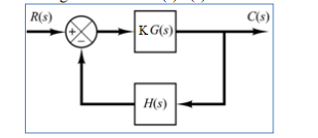

**Objective:**

* To plot the root locus for a given transfer function of the system using MATLAB
* To use the root locus techniques to analyze the effect of loop gain upon system’s transient response and stability

**Procedure :**

Q1

%

clc;

close all;

clear all;

num=[1 -4 20]; % Define numerator of Open Loop Transfer Function

den=[1 6 8]; % Define denominator of Open Loop Transfer Function

sys=tf(num,den)

rlocus(sys)

R=rlocus(sys,0)

R=rlocus(sys,inf)

R=rlocus(sys,1)

zeta=0.45;

wn=0;

sgrid(zeta,wn)

title ('Root Locus')

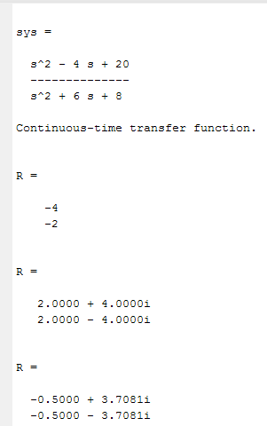

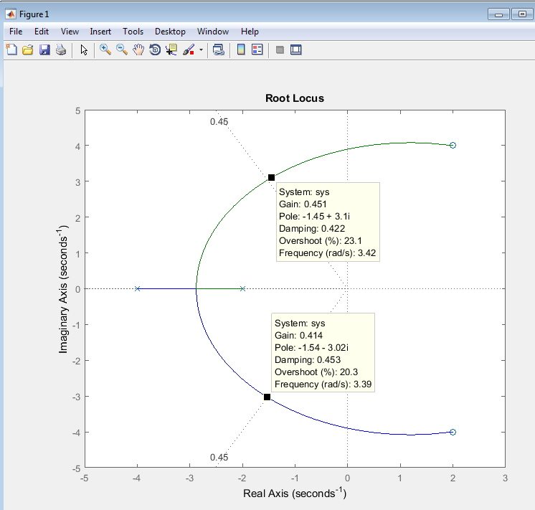

Q2)

% % Q2

clc;

close all;

clear all;

num=[1 9 20]; % Define numerator of Open Loop Transfer Function

den=[1 0 0]; % Define denominator of Open Loop Transfer Function

sys=tf(num,den)

rlocus(sys)

R=rlocus(sys,0)

R=rlocus(sys,inf)

zeta=0.667;

wn=3;

sgrid(zeta,wn)

title ('Root Locus')

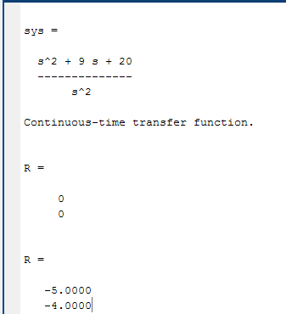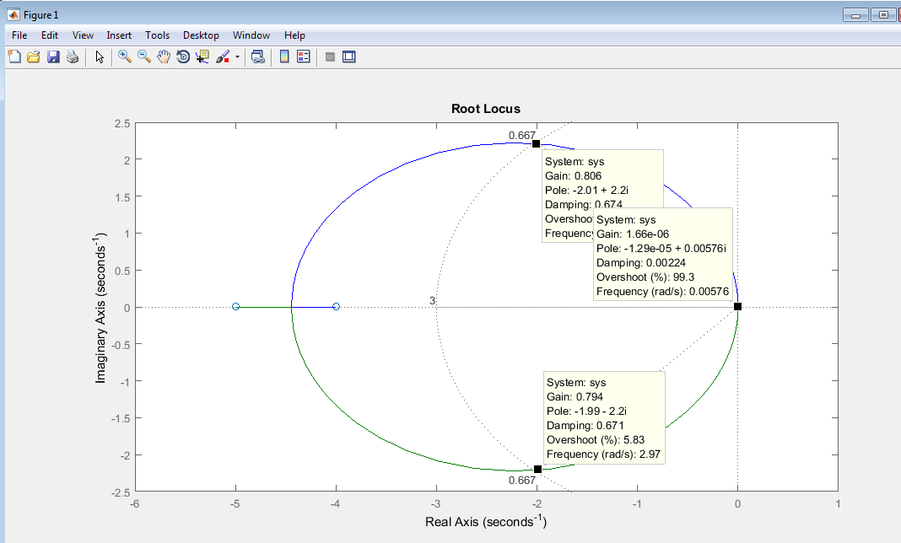

Q3

% %ex_3

clc;

close all;

clear all;

num=[0 0 0 1 3]; % Define numerator of Open Loop Transfer Function

den=[1 6 13 10 0]; % Define denominator of Open Loop Transfer Function

sys=tf(num,den)

rlocus(sys)

R=rlocus(sys,0)

R=rlocus(sys,inf)

zeta=0.35;

wn=[];

sgrid(zeta,wn)

title ('Root Locus')

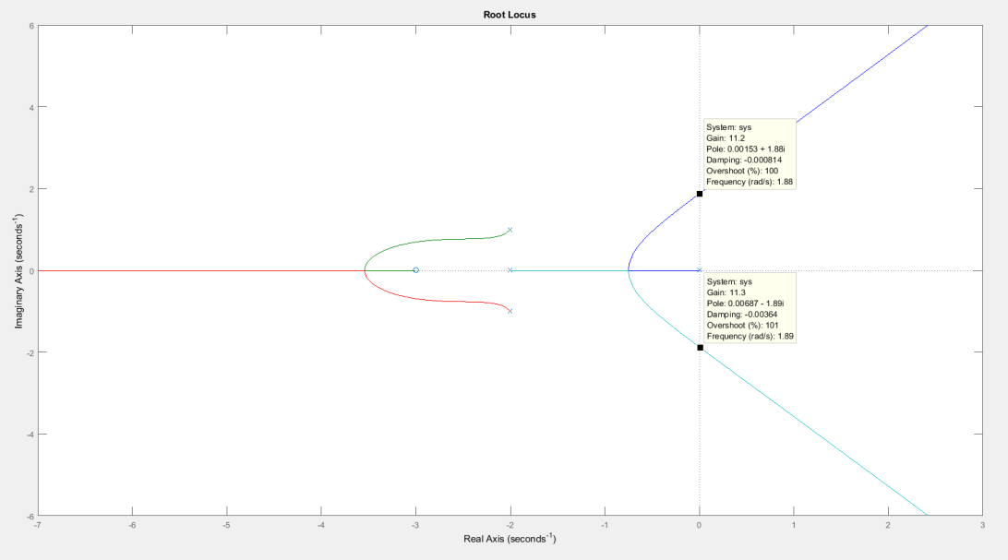3(b,c)

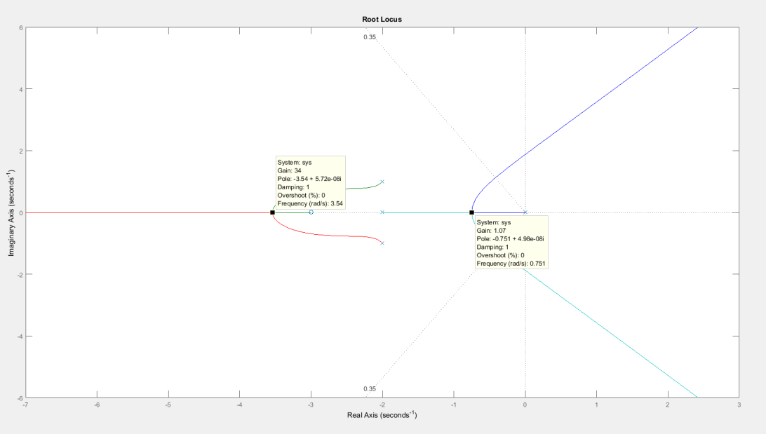

3(d)

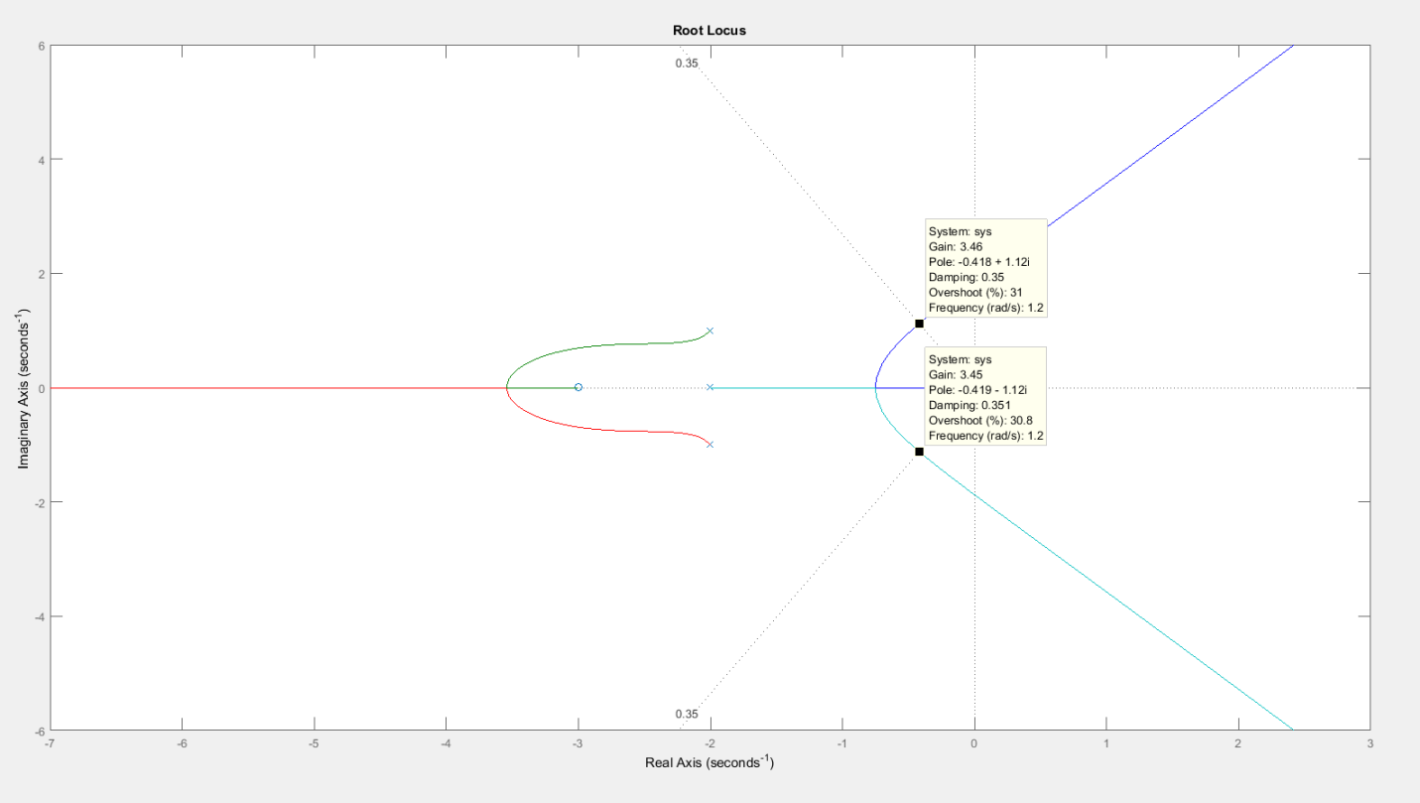

**Conclusion:**

After performing different types of operation on the root locus while designing the compensator. We know how to value design a compensator and what are their basic requirements, also calculated damping ratio and settling time of system

**Application:**

The Root Locus Plot technique can be applied to determine the dynamic response of the system. This method associates itself with the transient response of the system and is particularly useful in the investigation of stability characteristics of the system.

**Issues:**

No issue occurred .

**Post Lab:**

Question#1

G(s) = K

Solution:

The system is marginally stable.

num=[1300]; % Define numerator of Open Loop Transfer Function

den=[1 0 739600]; % Define denominator of Open Loop Transfer Function

sys=tf (num,den)

rlocus (sys) % Draw root locus

title ('Root Locus')

Question#2

G(s) =K(s+200)/(s+1000)

Solution:

The system is unstable.

num=[1300 260000]; % Define numerator of Open Loop Transfer Function

den=[1 1000 -739600 739600000]; % Define denominator of Open Loop Transfer Function

sys=tf (num,den)

rlocus (sys) % Draw root locus

title ('Root Locus')

